**Preliminary**

**Product Information**

**Microanalytical Reference Material**

**S-Fe isotope analysis for pyrrhotite**

**Natural crystal**

**(LL-Po)**

***This certificate is valid for five years after purchase***

***Sales date:***

***The minimums amount of sample to be used is ~200mg***

***NOTE***

***These materials have been developed by xx ().***

***Latest revision: April 2024***

***Signed:***

***Prof. xxx***

***Xxx***

***Xxx***

***Xxx***

1. **Description**

The sulfide samples (Figure 1a-c) in this study were collected from the Linglong golden deposit located in the Jiaodong area in the eastern part of the North China Craton. The deposit is one of the largest quartz vein-type gold deposits in Jiaodong, where the ore formation is mainly controlled by a NNE-NE trending fault zone. Here, the masses of these three massive sulfides are 6.4, 0.7 and 1.0 kg. Pure pyrrhotite fragments were picked and packed, called as LL-Po.



**Fig. 1 Photographs of massive sulfides**

**2. Analytical method**

**2.1 Sample preparation**

Pure pyrrhotite fragments were crushed with a steel mortar to 200-300 μm size. Any fragments with visible imperfections under a binocular microscope were removed. The clean fragments were selected randomly (30–40 fragments for each sample) and embedded in epoxy resin and carefully polished to obtained flat surfaces for microscopic observation. Parts of the fragments were used for bulk analyses using isotope ratio mass spectrometry (IRMS) and solution-MC-ICP-MS.

**2.2 Bulk S-Fe analysis using IRMS and MC-ICP-MS**

Bulk S-Fe analysis using IRMS and MC-ICP-MS from different labs. The analytical procedures please refer to Feng et al. (2024).

**2.3 In situ S-Fe isotopes analyses by fs-LA-MC-ICP-MS**

A NEPTUNE Plus MC-ICP-MS instrument (Thermo Fisher Scientific, Bremen, Germany) was combined with a NWR FemtoUC femtosecond system (New Wave Research, Fremont, CA, USA.) for theseexperiments. The analytical procedures please refer to Feng et al. (2024).

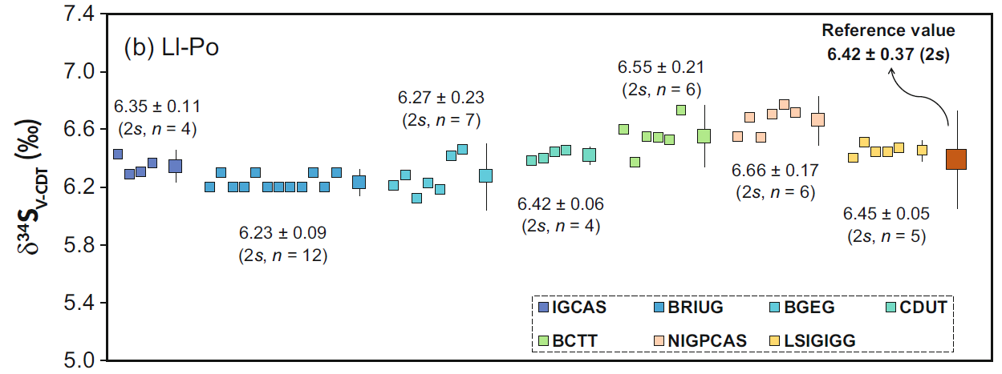

Fig. 1 The bulk sulfur isotope composition of LL-Po obtained in different laboratories. All of the samples were analyzed by IRMS except NWU by SN-MC-ICP-MS.

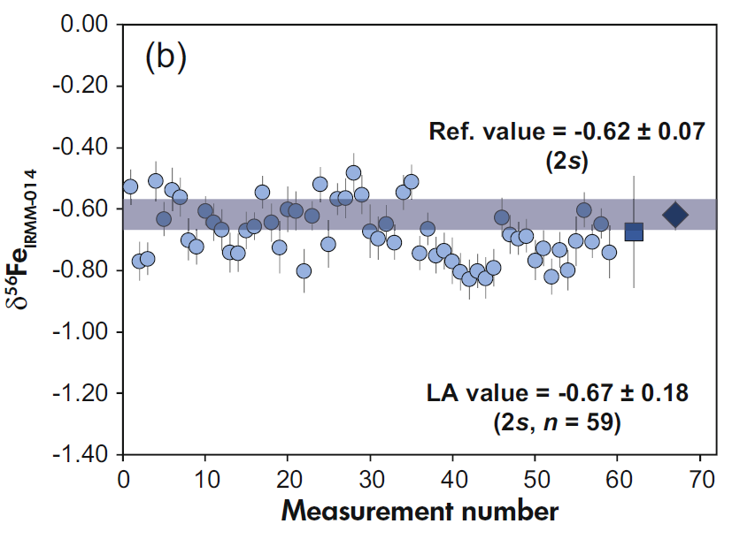

Fig. 2. Plots of iron isotopic composition in LL-Po. The circles and squares represent random laser ablation spot results and the mean results, respectively, while the rhombuses are the bulk values determined by SN-MC-ICP-MS. The range bar for a single analysis represents 2SE, and that for the mean value represents 2s. The uncertainty of the recommended value is the combined uncertainty

Table 1. S-Fe isotope composition in LL-Po.

|  |  |  |  |  |  |
| --- | --- | --- | --- | --- | --- |
|  | ***Methods*** | **S isotope** | | **Fe isotope** | |
| **δ34SV-CDT (‰)** | **2SD** | **δ56FeIRMM-014 (‰)** | **2SD** |
| **LL-Po** | ***IRMS MC-ICP-MS*** | 6.42 | 0.37 | -0.62 | 0.07 |
| ***LA-MC-ICP-MS*** | 6.28 | 0.35 | -0.67 | 0.18 |

**3. Intended Use**

This series of samples are mainly used for S-Fe isotope analysis of micro analysis, which are suitable for LA-MC-ICP-MS and SIMS. They can be used as calibration standards or unknown samples to monitor data quality (secondary reference material). Please note that each sample can only be used for a single purpose, for example, each sample cannot be used as both a calibration standard and an unknown sample during the same test.

**4. Storage and Handling**

Samples are recommended to be stored in a dry environment. Natural sulfide is stable at normal temperature and pressure. Do not contact dilute acid, sulfide is easily dissolved in dilute acid.

**5. Safety Instructions**

Natural sulfide is stable at room temperature and pressure, can be in contact with the skin, but can not be ingested into the body.

**6. Other Information**

The sulfide reference materials have been published in the SCI journal by Feng et al. (2024). Because samples are natural crystals, a small number of inclusions or cracks may appear. If users observe these inclusions or cracks during microanalysis, please avoid them.

**7. Legal Notice**

Neither sulfides, its subsidiaries, its contractors nor any person acting on their behalf

(a) Make any warranty or representation, express or implied that the use of any information, material, apparatus, method or process disclosed in this document does not infringe any privately owned intellectual property rights

(b) Assume any liability with respect to, or for damages resulting from, the use of any information, material, apparatus, method or process disclosed in this document save for loss or damage arising solely and directly from the negligence of sulfide or any of its subsidiaries.

(c) Our order, sales and delivery conditions apply. The valid version of our general terms and conditions - can be found on our website: https://www.my-standards.com/terms-and-conditions/. They are also available on request.

**8. References**

Feng, Y., Zhang, W., Hu, Z., Luo, T., Li, Q. and Liu, J. (2024), New Potential Sulfide Reference Materials for Microbeam S-Fe-Cu Isotope Measurements. Geostand Geoanal Res, 48: 227-244. https://doi.org/10.1111/ggr.12530

**9. Revision History**

(a): 3 April 2024, First publication Version 1.0.