**Preliminary**

**Product Information**

**Microanalytical Reference Material**

**Pb and Sr isotope analysis for K-feldspar**

**Natural crystal**

**(Tuyk)**

***This certificate is valid for five years after purchase***

***Sales date:***

***The minimums amount of sample to be used is ~200mg***

***NOTE***

***These materials have been developed by xx ().***

***Latest revision: April 2024***

***Signed:***

***Prof. xxx***

***Xxx***

***Xxx***

***Xxx***

1. **Description**

A K-feldspar megacryst (Tuyk) from a pegmatite deposit of Henan province in central China was selected as an in-house standard sample to monitor the analytical quality of the natural feldspars.

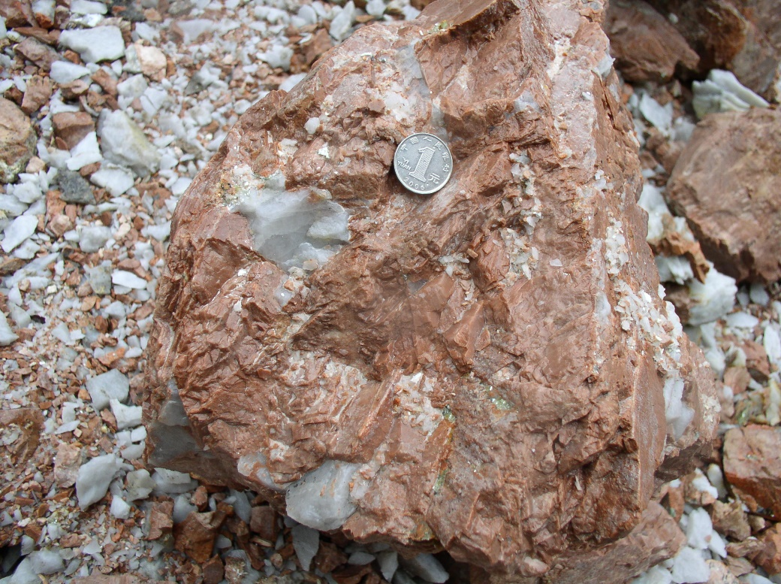

**Fig. 1 Photographs of K-feldspar megacryst**

**2. Analytical method**

**2.1 Sample preparation**

Tuyk crushed with a steel mortar to 1–2 mm size. Any fragments with visible imperfections under a binocular microscope were removed. The clean fragments were selected randomly (30–40 fragments for each sample) and embedded in epoxy resin and carefully polished to obtained flat surfaces for microscopic observation, major and trace elements analyses by LA-ICP-MS, respectively, Pb-Sr isotope analyses by LA-MC-ICP-MS. Parts of the fragments were used for bulk analyses using MC-ICP-MS.

**2.2 Concentration of trace elements**

Trace element compositions in Tuky were measured by using LA-ICP-MS. An Agilent 7900 quadrupole ICP-MS combined with a GeoLas Pro 193 nm excimer laser platforms were used. The laser ablation parameters were set at a spot size of 44 μm, a repetition rate of 5 Hz and a fluence of ~5 J cm-2. Each LA-ICP-MS analysis incorporated an approximately 20 s background acquisition followed by 50 s of data acquisition from the sample. NIST SRM 610 was repetitively analyzed every ten sample analyses for time-drift correction. BCR-2G, BHVO-2G and BIR-1G were used as external standards. The analytical results were listed in Table 1.

**Table 1. The trace elements in Tuky obtained from LA-ICP-MS**

|  |  |  |  |
| --- | --- | --- | --- |
|  |  | TUYK | |
|  |  | mean | 2SD |
| Na2O | wt% | 2.3 | 1.7 |
| MgO | wt% | 0.0 | 0.0 |
| Al2O3 | wt% | 18.4 | 0.6 |
| SiO2 | wt% | 65.5 | 0.6 |
| P2O5 | wt% | 0.0 | 0.0 |
| K2O | wt% | 13.0 | 2.6 |
| CaO | wt% | 0.0 | 0.0 |
| TiO2 | wt% | 0.0 | 0.0 |
| MnO | wt% | 0.0 | 0.0 |
| FeO | wt% | 0.1 | 0.0 |
| Co | μg g-1 | 0.00 | 0.01 |
| Ni | μg g-1 | 0.10 | 0.08 |
| Cu | μg g-1 | 0.26 | 0.34 |
| Zn | μg g-1 | 3.13 | 1.98 |
| Rb | μg g-1 | 285 | 80 |
| Sr | μg g-1 | 620 | 125 |
| Y | μg g-1 | 0.02 | 0.01 |
| Zr | μg g-1 | 0.02 | 0.02 |
| Nb | μg g-1 | 0.01 | 0.01 |
| Mo | μg g-1 | 0.01 | 0.02 |
| Ba | μg g-1 | 3291 | 463 |
| La | μg g-1 | 0.62 | 0.18 |
| Ce | μg g-1 | 0.36 | 0.11 |
| Pr | μg g-1 | 0.01 | 0.01 |
| Nd | μg g-1 | 0.02 | 0.03 |
| Sm | μg g-1 | 0.01 | 0.01 |
| Eu | μg g-1 | 0.33 | 0.10 |
| Gd | μg g-1 | 0.00 | 0.00 |
| Tb | μg g-1 | 0.00 | 0.00 |
| Dy | μg g-1 | 0.00 | 0.01 |
| Ho | μg g-1 | 0.00 | 0.00 |
| Er | μg g-1 | 0.00 | 0.00 |
| Tm | μg g-1 | 0.00 | 0.00 |
| Yb | μg g-1 | 0.00 | 0.00 |
| Lu | μg g-1 | 0.00 | 0.00 |
| Hf | μg g-1 | 0.01 | 0.01 |
| Ta | μg g-1 | 0.02 | 0.01 |
| Pb | μg g-1 | 59.55 | 15.70 |
| Th | μg g-1 | 0.00 | 0.00 |
| U | μg g-1 | 0.01 | 0.01 |

**2.3 Bulk Pb-Sr isotope analysis using MC-ICP-MS**

All chemical preparations were performed on class 100 work benches within a class 1000 over-pressured clean laboratory. Sample digestion: (1) Sample powder (200 mesh) were placed in an oven at 105 ℃ for drying of 12 hours; (2) 50-200 mg sample powder was accurately weighed and placed in an Teflon bomb; (3) 1-3 ml HNO3 and 1-3 ml HF were added into the Teflon bomb; (4) Teflon bomb was putted in a stainless steel pressure jacket and heated to 190 ℃ in an oven for >24 hours; (5) After cooling, the Teflon bomb was opened and placed on a hotplate at 140 ℃ and evaporated to incipient dryness, and then 1 ml HNO3 was added and evaporated to dryness again; (6) The sample was dissolved in 1.0 mL of 2.5 M HCl.

Column chemistry: Pb was separated using standard ion exchange procedures (Bio-Rad AG1-X8, 200–400 mesh resin) in HBr–HCl media. The total procedural blank was less than 20 pg. The Sr fraction was separated again by the Sr-specific resin. The solution was first converted to the HNO3 media (3 M HNO3). Then the solution was loaded into the Sr-specific resin and pre-conditioned with 6 M HCl and 3 M HNO3. After complete draining of the sample solution, columns were rinsed with 3 M HNO3 to remove undesirable matrix elements. Finally, Sr was eluted using MQ H2O and gently evaporated to dryness prior to mass-spectrometric measurement.

Pb isotopic compositions were determined using static mode on a Neptune Plus MC-ICP-MS (Thermo Fisher Scientific, Germany) using Faraday cups. After chemical separation, NBS 981 (NIST SRM 981) Pb standards and sample solutions were spiked with NIST-SRM 977 Tl. The samples and standards were adjusted to a consistent Pb/Tl ratio of 3:1 to reach appropriate ion currents in the range of 10–15 V total Pb. A modified Tl normalization technique was used to correct for the mass bias. In this method, the natural Tl-isotopic composition was assumed, and a series of reference samples were then run to define the mathematical relationship between Tl and Pb mass bias. This relationship could then be applied to the unknowns, providing a robust correction for any mass bias related to either instrument drift or matrix effects. The ion beam intensities for 202Hg were always below 0.17 mV for all runs, corresponding to a correction of less than 0.1 mV in mass for 204Hg. The samples were analyzed with the reference material NBS 981 run every two samples.

Sr isotope analyses were performed on a Neptune Plus MC-ICP-MS (Thermo Fisher Scientific, Dreieich, Germany). The faraday collector configuration of the mass system was composed of an array from L4 to H3 to monitor 83Kr+、167Er++、84Sr+、85Rb+、86Sr+、173Yb++、87Sr+、88Sr+. Sr single element solution from Alfa (Alfa Aesar, Karlsruhe, Germany) was used to optimize instrument operating parameters. An aliquot of the international standard solution of 200 μg L−1 NIST SRM 987 was used regularly for evaluating the reproducibility and accuracy of the instrument. Typically, the signal intensities of 88Sr in NIST 987 were > ~7.0 V. The Sr isotopic data were acquired in the static mode at low resolution. The routine data acquisition consisted of ten blocks of 10 cycles (4.194 s integration time per cycle). The total time of one measurement lasted about 7 minutes.

The exponential law was used to assess the instrumental mass discrimination in this study. Mass discrimination correction was carried out via internal normalization to a 88Sr/86Sr ratio of 8.375209. The interference elements Ca, Rb, Er, Yb have been completely separated by the exchange resin process. The remaining interferences of 83Kr+、85Rb+、167Er++、173Yb++ were corrected based on the mothed. One international NIST 987 standard was measured every seven samples analyzed. Analyses of the NIST 987 standard solution yielded 87Sr/86Sr ratio of 0.710242±14 (2SD, n=345), which is identical within error to their published values 0.710248±12).

The analysis results of Tuky were listed in Table 2 and Table3.

**Table 2 Pb isotope analysis using MC-ICP-MS and LA-MC-ICP-MS**

|  |  |  |  |  |  |
| --- | --- | --- | --- | --- | --- |
|  | **208Pb/206Pb** | **207Pb/206Pb** | **208Pb/204Pb** | **207Pb/204Pb** | **206Pb/204Pb** |
| Solution n = 4 | 2.19340 ± 0.00006 | 0.90157 ± 0.00001 | 37.549 ± 0.004 | 15.434 ± 0.001 | 17.119 ± 0.002 |
| Laser ablation n = 105 | 2.194 ± 0.002 | 0.9018 ± 0.0006 | 37.544 ± 0.067 | 15.429 ± 0.028 | 17.109 ± 0.034 |
| 2RSD (%) | 0.07 | 0.07 | 0.18 | 0.18 | 0.20 |
| Accuracy (%) | 0.05 | 0.03 | -0.02 | -0.03 | -0.06 |
| All uncertainties are expressed as 2SD | |  |  |  |  |

**Table 3 Sr isotope analysis using MC-ICP-MS and LA-MC-ICP-MS**

|  |  |  |  |  |  |  |  |
| --- | --- | --- | --- | --- | --- | --- | --- |
|  | **TIMS (n=3)** | **fs-LA-MC-ICP-MS** | | | **Sr** | **Rb** | **Rb/Sr** |
| **87Sr/86Sr** | **87Sr/86Sr** | **2SD** | **n** | **μg g-1** | |
| **Tuyk** | 0.710206±11 | 0.710325 | 0.000297 | 56 | 620 | 285 | 0.46 |

**2.4 Micro analysis of Pb-Sr isotope using LA-MC-ICP-MS**

Pb isotope ratios of Tuky were measured by a Neptune Plus MC-ICP-MS (Thermo Fisher Scientific, Bremen, Germany) using a combination of Faraday cups and ion counters (FC-IC) in combination with a Geolas HD excimer ArF laser ablation system (Coherent, Göttingen, Germany) at the Wuhan Sample Solution Analytical Technology Co., Ltd, Hubei, China. In the FC-IC array, 208Pb, 207Pb and 206Pb were measured using Faraday cups, and 204Pb and 202Hg were measured using three ICs mounted on the low mass Faraday cups. In the laser ablation system, helium was used as the carrier gas for the ablation cell and was mixed with argon (makeup gas) after the ablation cell. For a single laser spot ablation, the spot diameter ranged from 90 to 120 μm dependent on Pb signal intensity. The pulse frequency was from 8 to 10 Hz, but the laser fluence was kept constant at ~10 J/cm2. Prior to data acquisition, an area slightly larger than the target area was gently pre-ablated for a few seconds to remove any surface Pb contamination. As stable background signals during analytical sessions were obtained, the Pb and Hg backgrounds were subtracted directly from the measured ion beam intensities during ablation. 202Hg ion signal was used to monitor the isobaric interference of 204Hg on 204Pb and a mass bias correction was applied to the 204Hg/202Hg ratio using the natural 204Hg/202Hg ratio (0.2301) and the exponential law factor calculated from the average values of the 204Hg/202Hg ratio in the gas background. A calibrator-sample-calibrator bracketing method was employed to correct for instrumental mass fractionation, instrumental drift and any systematic electron-multiplier gain bias. BCR-2G and NIST 612 were chosen as reference materials to correct the instrumental mass fractionation.

Sr isotope ratios of Tuky were measured by a Neptune Plus MC-ICP-MS (Thermo Fisher Scientific, Bremen, Germany) in combination with a Geolas HD excimer ArF laser ablation system (Coherent, Göttingen, Germany). The Faraday collector configuration of the mass system was composed of an array from L4 to H3 to monitor Kr, Rb, Er, Yb and Sr. The combination of the high-sensitivity X-skimmer cone and Jet-sample cone was employed. In the laser ablation system, helium was used as the carrier gas for the ablation cell. For a single laser spot ablation, the spot diameter ranged from 44 to 60 μm dependent on Sr signal intensity. The pulse frequency was from 6 to 10 Hz, but the laser fluence was kept constant at ~10 J/cm2. The interference correction strategy was the following description: firstly, the regions of integration for both gas background and sample were selected. Following background correction, which removes the background Kr+ signals, no additional Kr peak stripping was applied. Interferences were corrected in the following sequence: (1) the interferences of 168Er++ on 84Sr, 170Er++ and 170Yb++ on 85Rb, 172Yb++ on 86Sr, and 174Yb++ on 87Sr were corrected based on the measured signal intensities of 167Er++, 173Yb++ and the natural isotope ratios of Er and Yb; (2) the isobaric interference of 87Rb on 87Sr was corrected by monitoring the 85Rb signal intensity and a user-specified 87Rb/85Rb ratio using an exponential law for mass bias. The user-specified 87Rb/85Rb ratio was calculated by measuring some reference materials BCR-2G (USGS glasses) with a known 87Sr/86Sr ratio. Following the interference corrections, mass fractionation of Sr isotopes was corrected by assuming 88Sr/86Sr = 8.375209 and applying the exponential law. The analytical results were listed in Table 2 and Table 3.

**3. Intended Use**

This series of samples are mainly used for S isotope analysis of micro analysis in Tuky, which are suitable for LA-MC-ICP-MS. They can be used as calibration standards or unknown samples to monitor data quality (secondary reference material). Please note that each sample can only be used for a single purpose, for example, each sample cannot be used as both a calibration standard and an unknown sample during the same test.

**4. Storage and Handling**

Samples are recommended to be stored in a dry environment. Natural K-feldspar is stable at normal temperature and pressure. Do not contact dilute acid, K-feldspar is easily dissolved in dilute acid.

**5. Safety Instructions**

Natural K-feldspar is calcium phosphate, stable at room temperature and pressure, can be in contact with the skin, but can not be ingested into the body.

**6. Other Information**

The apatite reference materials have been published in the SCI journal, Chemical Geology, by Zhang et al. (2018). Because Tuyk is natural crystal, a small number of inclusions or cracks may appear. If users observe these inclusions or cracks during microanalysis, please avoid them.

This series of samples is sold exclusively through xx.

**7. Legal Notice**

Neither Tuyk, its subsidiaries, its contractors nor any person acting on their behalf

(a) Make any warranty or representation, express or implied that the use of any information, material, apparatus, method or process disclosed in this document does not infringe any privately owned intellectual property rights

(b) Assume any liability with respect to, or for damages resulting from, the use of any information, material, apparatus, method or process disclosed in this document save for loss or damage arising solely and directly from the negligence of K-feldspar or any of its subsidiaries.

(c) Our order, sales and delivery conditions apply. The valid version of our general terms and conditions - can be found on our website: https://www.my-standards.com/terms-and-conditions/. They are also available on request.

**8. References**

Wen Zhang, Zhaochu Hu, Yongsheng Liu., et al. Improved Inter-calibration of Faraday Cup and Ion Counting for In Situ Pb Isotope Measurements Using LA-MC-ICP-MS: Application to the Study of the Origin of the Fangshan Pluton, North China. Geostandards Geoanalytical Research, 2016, 39(4), 467–487.

Wen Zhang, Zhaochu Hu, Yongsheng Liu., et al. Improved in situ Sr isotopic analysis by a 257 nm femtosecond laser in combination with the addition of nitrogen for geological minerals, Chemical Geology, 2018, 479, 10–21.

**9. Revision History**

(a): 3 April 2024, First publication Version 1.0.