Preliminary
Product Information
Microanalytical Reference Material

Pb isotope analysis for Sphalerite
Natural crystal
(Sph-HYLM)

This certificate is valid for five years after purchase
Sales date:
The minimums amount of sample to be used is ~200mg

NOTE
These materials have been developed by xx ().

Latest revision: April 2024

Signed:
Prof. xxx
Xxx
Xxx
Xxx

- Description
A sphalerite mineral, Sph-HYLM (Pb = ~394 μg g⁻¹), was collected from a Limei Pb-Zn deposit at the Huayuan ore concentration area in north-western Hunan Province.

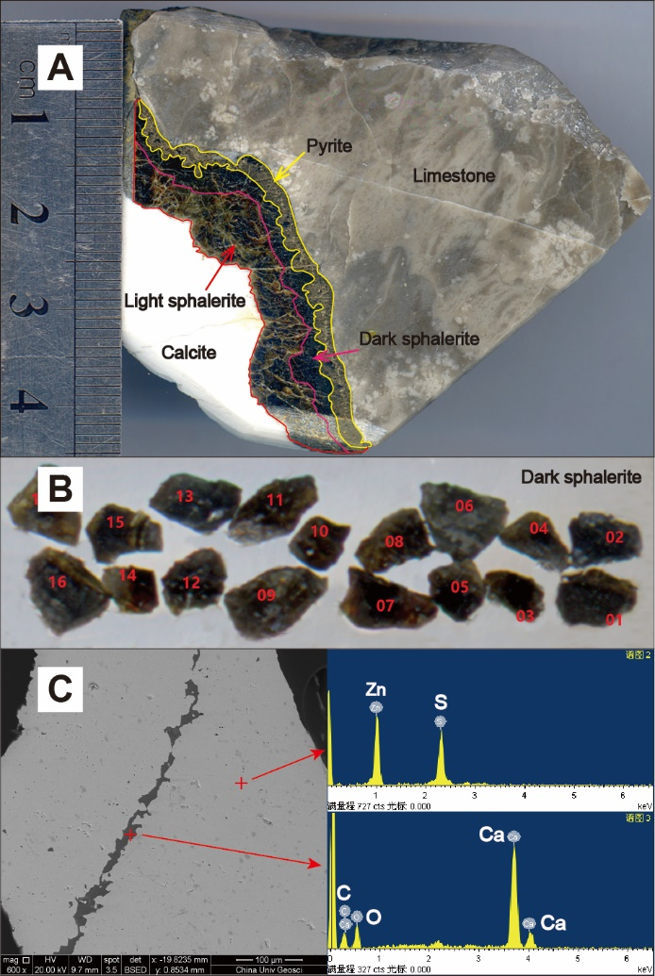

Fig. 1 Photographs of Sph-HYLM megacryst

2. Analytical method
2.1 Sample preparation
Sph-HYLM crushed with a steel mortar to 1–2 mm size. Any fragments with visible imperfections under a binocular microscope were removed. The clean fragments were selected randomly (30–40 fragments for each sample) and embedded in epoxy resin and carefully polished to obtained flat surfaces for microscopic observation, major and trace elements analyses by LA-ICP-MS, respectively, Pb isotope analyses by LA-MC-ICP-MS. Parts of the fragments were used for bulk analyses using MC-ICP-MS.

2.2 Bulk Pb isotope analysis using MC-ICP-MS
All chemical preparations were performed on class 100 work benches within a class 1000 over-pressured clean laboratory. Sample digestion: (1) Sample powder (200 mesh) were placed in an oven at 105 ℃ for drying of 12 hours; (2) 50-200 mg sample powder was accurately weighed and placed in an Teflon bomb; (3) 1-3 ml HNO₃ and 1-3 ml HF were added into the Teflon bomb; (4) Teflon bomb was putted in a stainless steel pressure jacket and heated to 190 ℃ in an oven for >24 hours; (5) After cooling, the Teflon bomb was opened and placed on a hotplate at 140 ℃ and evaporated to incipient dryness, and then 1 ml HNO₃ was added and evaporated to dryness again; (6) The sample was dissolved in 1.0 mL of 2.5 M HCl.
Pb was separated using standard ion exchange procedures (Bio-Rad AG1-X8, 200–400 mesh resin) in HBr–HCl media. Pb isotopic compositions were determined using static mode on a Neptune Plus MC-ICP-MS (Thermo Fisher Scientific, Germany) using Faraday cups. After chemical separation, NBS 981 (NIST SRM 981) Pb standards and sample solutions were spiked with NIST-SRM 977 Tl. The samples and standards were adjusted to a consistent Pb/Tl ratio of 3:1 to reach appropriate ion currents in the range of 10–15 V total Pb. A modified Tl normalization technique was used to correct for the mass bias. In this method, the natural Tl-isotopic composition was assumed, and a series of reference samples were then run to define the mathematical relationship between Tl and Pb mass bias. This relationship could then be applied to the unknowns, providing a robust correction for any mass bias related to either instrument drift or matrix effects. The ion beam intensities for ²⁰²Hg were always below 0.17 mV for all runs, corresponding to a correction of less than 0.1 mV in mass for ²⁰⁴Hg. The samples were analyzed with the reference material NBS 981 run every two samples.
The analysis results of Sph-HYLM were listed in Table 2.

Table 2 Pb isotope analysis using MC-ICP-MS and LA-MC-ICP-MS

 |  |  | ²⁰⁸Pb/²⁰⁶Pb |  | ²⁰⁷Pb/²⁰⁶Pb |  | ²⁰⁸Pb/²⁰⁴Pb |  | ²⁰⁷Pb/²⁰⁴Pb |  | ²⁰⁶Pb/²⁰⁴Pb
Sample |  |  | Average | 2SD | Average | 2SD | Average | 2SD | Average | 2SD | Average | 2SD
Sph-HYLM | LA-MC | n=64 | 2.1150 | 0.0004 | 0.86579 | 0.00034 | 38.516 | 0.020 | 15.767 | 0.007 | 18.211 | 0.010
 | Solution | n=6 | 2.1148 | 0.0001 | 0.86585 | 0.00018 | 38.504 | 0.011 | 15.764 | 0.002 | 18.207 | 0.006

2.3 Micro analysis of Pb isotope using LA-MC-ICP-MS
Pb isotope ratios of Sph-HYLM were measured by a Neptune Plus MC-ICP-MS (Thermo Fisher Scientific, Bremen, Germany) using a combination of Faraday cups and ion counters (FC-IC) in combination with a Geolas HD excimer ArF laser ablation system (Coherent, Göttingen, Germany) at the Wuhan Sample Solution Analytical Technology Co., Ltd, Hubei, China. In the FC-IC array, ²⁰⁸Pb, ²⁰⁷Pb and ²⁰⁶Pb were measured using Faraday cups, and ²⁰⁴Pb and ²⁰²Hg were measured using three ICs mounted on the low mass Faraday cups. In the laser ablation system, helium was used as the carrier gas for the ablation cell and was mixed with argon (makeup gas) after the ablation cell. For a single laser spot ablation, the spot diameter ranged from 90 to 120 μm dependent on Pb signal intensity. The pulse frequency was from 8 to 10 Hz, but the laser fluence was kept constant at ~10 J/cm². Prior to data acquisition, an area slightly larger than the target area was gently pre-ablated for a few seconds to remove any surface Pb contamination. As stable background signals during analytical sessions were obtained, the Pb and Hg backgrounds were subtracted directly from the measured ion beam intensities during ablation. ²⁰²Hg ion signal was used to monitor the isobaric interference of ²⁰⁴Hg on ²⁰⁴Pb and a mass bias correction was applied to the ²⁰⁴Hg/²⁰²Hg ratio using the natural ²⁰⁴Hg/²⁰²Hg ratio (0.2301) and the exponential law factor calculated from the average values of the ²⁰⁴Hg/²⁰²Hg ratio in the gas background. A calibrator-sample-calibrator bracketing method was employed to correct for instrumental mass fractionation, instrumental drift and any systematic electron-multiplier gain bias. MASS-1 were chosen as reference materials to correct the instrumental mass fractionation. The analysis results of Sph-HYLM were listed in Table 2.

3. Intended Use
This series of samples are mainly used for S isotope analysis of micro analysis in Tuky, which are suitable for LA-MC-ICP-MS. They can be used as calibration standards or unknown samples to monitor data quality (secondary reference material). Please note that each sample can only be used for a single purpose, for example, each sample cannot be used as both a calibration standard and an unknown sample during the same test.

4. Storage and Handling
Samples are recommended to be stored in a dry environment. Natural Sphalerite is stable at normal temperature and pressure. Do not contact dilute acid, Sphalerite is easily dissolved in dilute acid.
5. Safety Instructions
Natural Sphalerite is calcium phosphate, stable at room temperature and pressure, can be in contact with the skin, but can not be ingested into the body.

6. Other Information
The apatite reference materials have been published in the SCI journal. Because Sph-HYLM is natural crystal, a small number of inclusions or cracks may appear. If users observe these inclusions or cracks during microanalysis, please avoid them.
This series of samples is sold exclusively through xx.

7. Legal Notice
Neither Sph-HYLM, its subsidiaries, its contractors nor any person acting on their behalf
(a) Make any warranty or representation, express or implied that the use of any information, material, apparatus, method or process disclosed in this document does not infringe any privately owned intellectual property rights
(b) Assume any liability with respect to, or for damages resulting from, the use of any information, material, apparatus, method or process disclosed in this document save for loss or damage arising solely and directly from the negligence of Sphalerite or any of its subsidiaries.
(c) Our order, sales and delivery conditions apply. The valid version of our general terms and conditions - can be found on our website: https://www.my-standards.com/terms-and-conditions/. They are also available on request.

8. References
Wen Zhang, Zhaochu Hu*, Detlef Günther, Yongsheng Liu, Wenli Ling, Keqing Zong, Haihong Chen, Shan Gao, Direct lead isotope analysis in Hg-rich sulfides by LA-MC-ICP-MS with a gas exchange device and matrix-matched calibration, Analytica Chimica Acta, 2016, 948, 9-18.

9. Revision History
(a): 3 April 2024, First publication Version 1.0.

