Preliminary
Product Information
Microanalytical Reference Material

Sr isotope analysis for Calcites
Natural crystal
(AUS, HLP-3, SXD)

This certificate is valid for five years after purchase
Sales date:
The minimums amount of sample to be used is ~200mg

NOTE
These materials have been developed by xx ().

Latest revision: April 2024

Signed:
Prof. xxx
Xxx
Xxx
Xxx

- Description
The calcite of AUS (>600g) was from Australia. HLP-3 was from Huanglongpu molybdenum mine in Shangluo City, Shanxi province, China. SXD was from Shiyan City, Hubei Province, China.

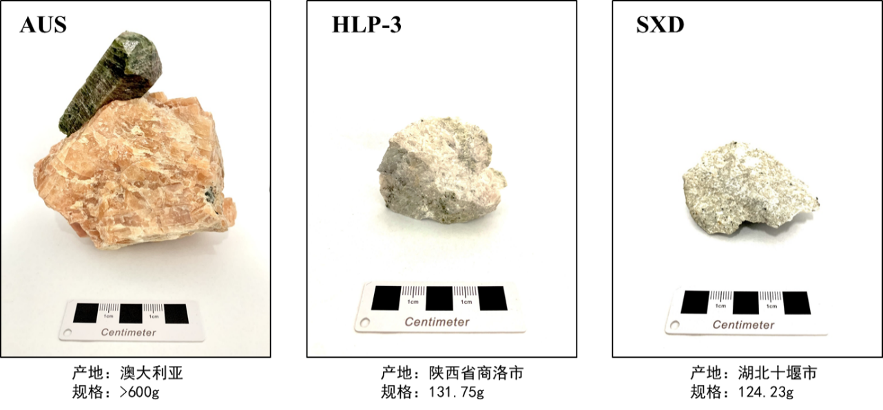
Fig. 1 Photographs of natural calcites

2. Analytical method
2.1 Sample preparation
Calcite samples were crushed with a steel mortar to 1–2 mm size. Any fragments with visible imperfections under a binocular microscope were removed. The clean fragments were selected randomly (30–40 fragments for each sample) and embedded in epoxy resin and carefully polished to obtained flat surfaces for microscopic observation, major and trace elements analyses by LA-ICP-MS, respectively, Sr isotope analyses by LA-MC-ICP-MS. Parts of the fragments were used for bulk analyses using MC-ICP-MS.

2.2 Concentration of trace elements
Trace element compositions in calcite were measured by using LA-ICP-MS. An Agilent 7900 quadrupole ICP-MS combined with a GeoLas Pro 193 nm excimer laser platforms were used. The laser ablation parameters were set at a spot size of 44 μm, a repetition rate of 5 Hz and a fluence of ~5 J cm⁻². Each LA-ICP-MS analysis incorporated an approximately 20 s background acquisition followed by 50 s of data acquisition from the sample. NIST SRM 610 was repetitively analyzed every ten sample analyses for time-drift correction. BCR-2G, BHVO-2G and BIR-1G were used as external standards. The analytical results were listed in Table 1.

Table 1. The trace elements in calcites obtained from LA-ICP-MS

Element | Unit | AUS | SXD | HLP-3
 |  | Laser | Laser | Laser
Rb | μg g⁻¹ | 0.01 | 0.04 | 0.07
Sr | μg g⁻¹ | 2365 | 5896 | 6898
Y | μg g⁻¹ | 100 | 468 | 738
Zr | μg g⁻¹ | 0.03 | 0.25 | 0.01
Cs | μg g⁻¹ | 8.12 | 38.36 | 32.59
Ba | μg g⁻¹ | 107 | 99.5 | 79.2
La | μg g⁻¹ | 291 | 341 | 316
Ce | μg g⁻¹ | 39.3 | 50.3 | 50.8
Pr | μg g⁻¹ | 155 | 242 | 253
Nd | μg g⁻¹ | 25.1 | 52.0 | 68.0
Sm | μg g⁻¹ | 4.43 | 15.7 | 21.7
Eu | μg g⁻¹ | 17.1 | 54.9 | 78.1
Gd | μg g⁻¹ | 2.14 | 8.3 | 12.6
Tb | μg g⁻¹ | 13.1 | 56.2 | 88.1
Dy | μg g⁻¹ | 3.00 | 13.6 | 21.9
Ho | μg g⁻¹ | 9.42 | 48.1 | 76.3
Er | μg g⁻¹ | 1.46 | 7.92 | 12.6
Tm | μg g⁻¹ | 10.03 | 56.6 | 85.8
Yb | μg g⁻¹ | 1.66 | 8.56 | 12.3
Lu | μg g⁻¹ | 0.00 | 0.00 | 0.01
Hf | μg g⁻¹ | 0.00 | 0.00 | 0.00
Nb | μg g⁻¹ | 0.00 | 0.01 | 0.01
Ta | μg g⁻¹ | 0.00 | 0.02 | 0.17
W | μg g⁻¹ | 0.00 | 0.00 | 0.00
Hg | μg g⁻¹ | 15.7 | 68.6 | 68.5

2.3 Bulk Sr isotope analysis using MC-ICP-MS
All chemical preparations were performed on class 100 work benches within a class 1000 over-pressured clean laboratory. Sample digestion: (1) Sample powder (200 mesh) were placed in an oven at 105 ℃ for drying of 12 hours; (2) 50-200 mg sample powder was accurately weighed and placed in an Teflon bomb; (3) 1-3 ml HNO₃ and 1-3 ml HF were added into the Teflon bomb; (4) Teflon bomb was putted in a stainless steel pressure jacket and heated to 190 ℃ in an oven for >24 hours; (5) After cooling, the Teflon bomb was opened and placed on a hotplate at 140 ℃ and evaporated to incipient dryness, and then 1 ml HNO₃ was added and evaporated to dryness again; (6) The sample was dissolved in 1.0 mL of 2.5 M HCl.
Column chemistry: The Sr fraction was separated again by the Sr-specific resin. The solution was first converted to the HNO₃ media (3 M HNO₃). Then the solution was loaded into the Sr-specific resin and pre-conditioned with 6 M HCl and 3 M HNO₃. After complete draining of the sample solution, columns were rinsed with 3 M HNO₃ to remove undesirable matrix elements. Finally, Sr was eluted using MQ H₂O and gently evaporated to dryness prior to mass-spectrometric measurement.
Sr isotope analyses were performed on a Neptune Plus MC-ICP-MS (Thermo Fisher Scientific, Dreieich, Germany). The faraday collector configuration of the mass system was composed of an array from L4 to H3 to monitor ⁸³Kr+、¹⁶⁷Er++、⁸⁴Sr+、⁸⁵Rb+、⁸⁶Sr+、¹⁷³Yb++、⁸⁷Sr+、⁸⁸Sr+. Sr single element solution from Alfa (Alfa Aesar, Karlsruhe, Germany) was used to optimize instrument operating parameters. An aliquot of the international standard solution of 200 μg L⁻¹ NIST SRM 987 was used regularly for evaluating the reproducibility and accuracy of the instrument. Typically, the signal intensities of ⁸⁸Sr in NIST 987 were > ~7.0 V. The Sr isotopic data were acquired in the static mode at low resolution. The routine data acquisition consisted of ten blocks of 10 cycles (4.194 s integration time per cycle). The total time of one measurement lasted about 7 minutes.
The exponential law was used to assess the instrumental mass discrimination in this study. Mass discrimination correction was carried out via internal normalization to a ⁸⁸Sr/⁸⁶Sr ratio of 8.375209. The interference elements Ca, Rb, Er, Yb have been completely separated by the exchange resin process. The remaining interferences of ⁸³Kr+、⁸⁵Rb+、¹⁶⁷Er++、¹⁷³Yb++ were corrected based on the mothed. One international NIST 987 standard was measured every seven samples analyzed. Analyses of the NIST 987 standard solution yielded ⁸⁷Sr/⁸⁶Sr ratio of 0.710242±14 (2SD, n=345), which is identical within error to their published values 0.710248±12). The analysis results of calcites were listed in Table 2.

Table 2 Bulk Sr isotope analysis using MC-ICP-MS

Sample | Rb(μg g⁻¹) | Sr(μg g⁻¹) | ⁸⁷Sr/⁸⁶Sr | 2sd | n | Methods
AUS | 0.04 | 2365 | 0.704255 | 0.000008 | 3 | Solution
 |  |  | 0.70423 | 0.000051 | 144 | Laser
SXD | 0.01 | 5896 | 0.703254 | 0.000008 | 3 | Solution
 |  |  | 0.70322 | 0.000060 | 50 | Laser
HLP-3 | 0.07 | 6898 | 0.705158 | 0.000008 | 3 | Solution
 |  |  | 0.70516 | 0.000042 | 63 | Laser

2.4 Micro analysis of Sr isotope using LA-MC-ICP-MS
Sr isotope ratios of calcites were measured by a Neptune Plus MC-ICP-MS (Thermo Fisher Scientific, Bremen, Germany) in combination with a Geolas HD excimer ArF laser ablation system (Coherent, Göttingen, Germany). The Faraday collector configuration of the mass system was composed of an array from L4 to H3 to monitor Kr, Rb, Er, Yb and Sr. The combination of the high-sensitivity X-skimmer cone and Jet-sample cone was employed. In the laser ablation system, helium was used as the carrier gas for the ablation cell. For a single laser spot ablation, the spot diameter ranged from 44 to 60 μm dependent on Sr signal intensity. The pulse frequency was from 6 to 10 Hz, but the laser fluence was kept constant at ~10 J/cm². The interference correction strategy was the following description: firstly, the regions of integration for both gas background and sample were selected. Following background correction, which removes the background Kr+ signals, no additional Kr peak stripping was applied. Interferences were corrected in the following sequence: (1) the interferences of ¹⁶⁸Er++ on ⁸⁴Sr, ¹⁷⁰Er++ and ¹⁷⁰Yb++ on ⁸⁵Rb, ¹⁷²Yb++ on ⁸⁶Sr, and ¹⁷⁴Yb++ on ⁸⁷Sr were corrected based on the measured signal intensities of ¹⁶⁷Er++, ¹⁷³Yb++ and the natural isotope ratios of Er and Yb; (2) the isobaric interference of ⁸⁷Rb on ⁸⁷Sr was corrected by monitoring the ⁸⁵Rb signal intensity and a user-specified ⁸⁷Rb/⁸⁵Rb ratio using an exponential law for mass bias. The user-specified ⁸⁷Rb/⁸⁵Rb ratio was calculated by measuring some reference materials BCR-2G (USGS glasses) with a known ⁸⁷Sr/⁸⁶Sr ratio. Following the interference corrections, mass fractionation of Sr isotopes was corrected by assuming ⁸⁸Sr/⁸⁶Sr = 8.375209 and applying the exponential law. The analytical results were listed in Table 2.

3. Intended Use
This series of samples are mainly used for S isotope analysis of micro analysis in calcite, which are suitable for LA-MC-ICP-MS. They can be used as calibration standards or unknown samples to monitor data quality (secondary reference material). Please note that each sample can only be used for a single purpose, for example, each sample cannot be used as both a calibration standard and an unknown sample during the same test.

4. Storage and Handling
Samples are recommended to be stored in a dry environment. Natural calcite is stable at normal temperature and pressure. Do not contact dilute acid, calcite is easily dissolved in dilute acid.
5. Safety Instructions
Natural calcite is calcium phosphate, stable at room temperature and pressure, can be in contact with the skin, but can not be ingested into the body.

6. Other Information
Because samples are natural calcite crystals, a small number of inclusions or cracks may appear. If users observe these inclusions or cracks during microanalysis, please avoid them.
This series of samples is sold exclusively through xx.

7. Legal Notice
Neither calcite, its subsidiaries, its contractors nor any person acting on their behalf
(a) Make any warranty or representation, express or implied that the use of any information, material, apparatus, method or process disclosed in this document does not infringe any privately owned intellectual property rights
(b) Assume any liability with respect to, or for damages resulting from, the use of any information, material, apparatus, method or process disclosed in this document save for loss or damage arising solely and directly from the negligence of calcites or any of its subsidiaries.
(c) Our order, sales and delivery conditions apply. The valid version of our general terms and conditions - can be found on our website: https://www.my-standards.com/terms-and-conditions/. They are also available on request.

8. References

9. Revision History
(a): 3 April 2024, First publication Version 1.0.

